

Recycling Dates: April 14th & 28th
Trash: Every Wednesday
Recycling: Every other Thursday

*For a regularly updated recyclable and
non-recyclable items list, visit: www.nwialandfill.com/recycle

 On-Call Numbers
If you need to contact the City outside of normal working hours please use the following numbers:
(712) 930-5444 – Gas, Water & Sewer
(712) 930-5222 – Electric

It’s that time again! The end of the Budget Billing cycle is here. We have included a separate page related to Budget Billing. Please make sure to review it so you are aware of the important information and dates regarding your account. The Budget flyer also has an image of a utility bill which explains how to monitor your budget account status each month.


Q: Which kind of bulbs were once exchanged as
a form of currency?



The City of Sanborn is still searching for a part-time Parks & Rec Director as well as Lifeguards. Interested applicants can go online to: https://www.sanborniowa.gov/jobs or stop and pick up an application at City Hall.


The Mi’Ono Club of Sanborn is still at it! The ladies of the Mi’ono club continue to spend countless hours updating Roseland Cemetery! The old shed is in the process of being turned into an information center for the cemetery. They will be hosting an open house on the Saturday before Memorial Day! There will be more information to come on Facebook as well as in our May newsletter. Keep your calendars open!


The 2024 Golf Season is upon us! Membership forms were mailed out last week! If you did not receive one and would like to join, they can be picked up at City Hall or at the Golf Course. The Annual “Golf Tee-Off” will be held Friday, April 19th at 6:30 out at the golf course.



We welcome Burt Van Dam as the SGCC restaurant & bar manager! Burt and his crew have been working to create a great menu. Keep an eye on Facebook for an opening date! We look forward to seeing you there!

FILL-IN
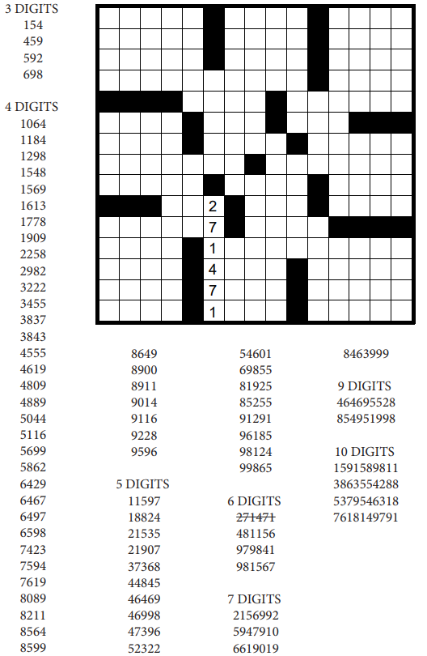

A: Tulip




Wednesday, May 1st : 4PM-7PM &
Saturday, May 4th : 8AM-12PM

Residents may bring all items for disposal to the City Maintenance Shed @ 205 Prospect Street
(across from the Sanborn Christian School).
City Staff will be on site to assist you.

*All items must be paid for at drop off. Payments will NOT be accepted at City Hall.

Appliance & TV Charges
- Appliances $15.00
(includes A/C units, clothes dryers, clothes washers, dehumidifiers, freezers, furnaces, stoves, microwaves, dishwashers, refrigerators, and water heaters)
- Computer Printers $ 5.00
- Computer Towers $10.00
- Computer Monitors/Laptops $15.00
- All TVs $20.00
- Large Copiers $35.00

**We will NOT accept tires, concrete, or construction waste. Hazardous Waste Drop Off will take place in the fall during the Fall Clean Up. Toxic waste includes degreasers, waxes, polishes, solvents, lacquers, thinners, caustic household cleaners, spot & stain removers, pesticides, herbicides, and oil-based paint.

Clean Up Days are intended for Sanborn residents only. Landlords with empty units, residents doing heavy construction, and commercial businesses should contact Brommer Sanitation at 712-722-0631 to arrange dumpster deliveries and pickups.

